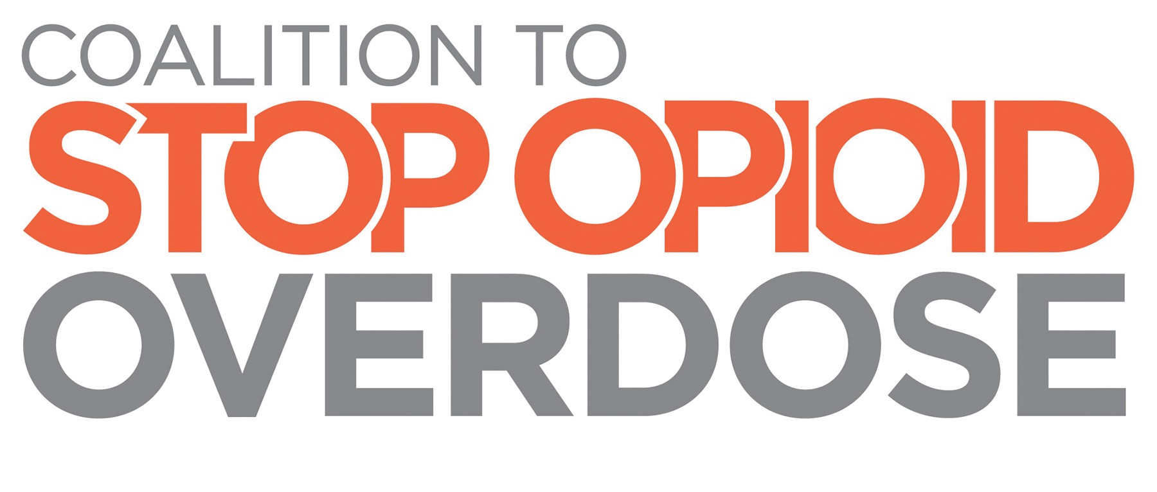
Frequently Asked Questions (FAQ)

Q: How is the Coalition to Stop Opioid Overdose different from other similar organizations?
A: The Coalition is focused solely on achieving consensus around simple and achievable prevention, treatment and recovery policies that can reduce opioid overdose. It has brought together diverse stakeholders as a unified group to ensure that Congress sends meaningful legislation to the President’s desk this year.
Q: It appears that legislation is advancing in Congress, why is a Coalition needed?
A: The level of interest within Congress to address the nationwide opioid epidemic presents an important window of opportunity to secure enactment of a comprehensive policy response to opioid overdose. The Coalition exists to ensure that all the legislative activity produces a meaningful result.
Q: Why aren’t the more than 30 bills aimed at addressing opioid misuse, overdose and addiction already introduced in Congress, including the Comprehensive Addiction and Recovery Act (CARA), enough?
A: Not any one of the bills currently introduced in Congress includes all of the public health strategies and tactics needed to combat the opioid epidemic. Many of these bills, including CARA, are aimed at authorizing programs rather than engendering public health change. The Coalition to Stop Opioid Overdose is committed to advancing policies that:
- Improve access to medication-assisted treatment for those with opioid addiction.
- Expand availability of naloxone in healthcare settings and beyond.
- Enhance prescription drug monitoring programs that track the dispensing and prescribing of controlled substances.
- Raise the level of opioid prescriber education.
Q: What legislation is the Coalition specifically supporting?
A: While individual organizations of the Coalition may have positions on the various legislative proposals currently moving through Congress, the Coalition has not yet taken a position on any specific bill, with the exception of supporting the passage and enactment of the Comprehensive Addiction and Recovery Act.
Q: Will there be a need for a Coalition if legislation is enacted this year?
A: Yes. The Coalition to Stop Opioid Overdose will be vital from enactment through to implementation.
Q: How is the Coalition to Stop Opioid Overdose being funded?
A: The formation of the Coalition to Stop Opioid Overdose was supported by the American Society of Addiction Medicine. ASAM is actively soliciting financial support for the Coalition from both non-profit organizations and for-profit companies, including health plans, pharmaceutical companies and diagnostic companies. Financial support for the Coalition is provided by the following: Adapt Pharma, The American Society of Addiction Medicine, CleanSlate Centers, Indivior, Merck and Proove.

