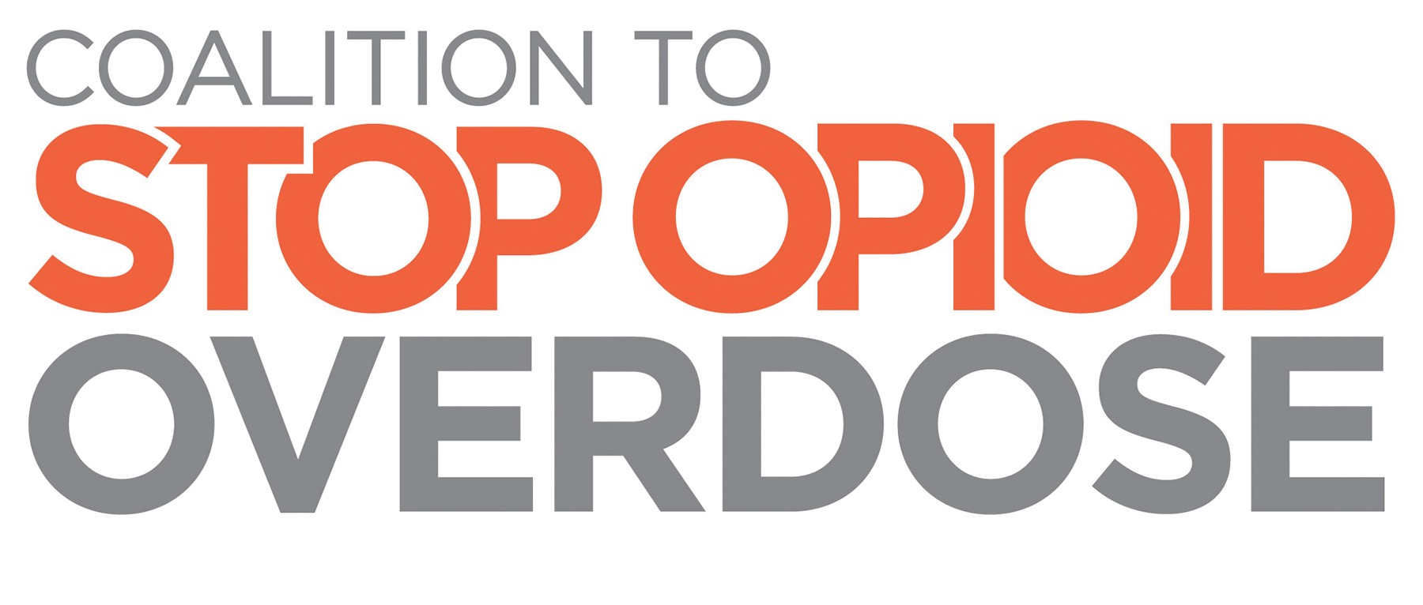

Opioid Misuse & Overdose: A Public Health Crisis in the U.S.

Opioids are a class of drugs that include heroin, as well as prescription pain relievers oxycodone, hydrocodone, codeine, morphine, fentanyl and others. Rates of opioid misuse and overdose in the United States are rising rapidly, despite increased awareness and current interventions.
- More than 10 million Americans reported using prescription opioids for nonmedical purposes in 2014.
  - 467,000 adolescents were current nonmedical users of pain relievers, with 168,000 having an addiction to prescription pain relievers (as of 2014).
  - Women are more likely to have chronic pain, be prescribed pain relievers, be given higher doses, and use them for longer time periods than men.
  - More than half of Americans (56 percent) say that they or someone they know has misused, been addicted to, or died from prescription pain medications.

Addiction is a chronic disease that too often goes untreated. When patients can’t access treatment and recovery support services, addiction can lead to disability or premature death.
- Emergency room visits linked to misuse of prescription opioids are up by more than 50 percent since 2004.
- An average of 129 Americans die each day from drug overdose, and more than half of deaths are from prescription drugs.
  - The rate of death from opioid-related overdose has quadrupled since 2000.
  - Opioids were involved in 28,647 deaths in 2014.
  - Prescription pain reliever overdose deaths among women increased more than 400 percent from 1999 to 2010, compared to a 237 percent increase among men.

While the opioid epidemic impacts the nation as a whole, some states are harder hit. In 2014, the five states with the highest rates of death due to drug overdose were:

- West Virginia
- New Mexico
- New Hampshire
- Kentucky
- Ohio

This problem continues to grow. Eight states saw a 15 percent or greater increase in the rate of deaths due to overdose from 2013 to 2014.

Center for Behavioral Health Statistics and Quality. 2014 National Survey on Drug Use and Health: detailed tables. Rockville, MD: Substance Abuse and Mental Health Services Administration, 2015.
Substance Abuse and Mental Health Services Administration, Center for Behavioral Health Statistics and Quality. (2015). Behavioral health trends in the United States: Results from the 2014 National Survey on Drug Use and Health. Rockville, MD: Substance Abuse and Mental Health Services Administration. Available online at http://www.samhsa.gov/data/sites/default/files/NSDUH-FRR1-2014/NSDUH-FRR1-2014.pdf.
Substance Abuse and Mental Health Services Administration, Center for Behavioral Health Statistics and Quality. (2015). Behavioral health trends in the United States: Results from the 2014 National Survey on Drug Use and Health. Rockville, MD: Substance Abuse and Mental Health Services Administration. Available online at http://www.samhsa.gov/data/sites/default/files/NSDUH-FRR1-2014/NSDUH-FRR1-2014.pdf.
Kaiser Health Tracking Poll: November 2015. Available online at: http://kff.org/health-reform/poll-finding/kaiser-health-tracking-poll-november-2015/.
Substance Abuse and Mental Health Services Administration. Highlights of the 2011 Drug Abuse Warning Network (DAWN) findings on drug-related emergency department visits. The DAWN Report. Rockville, MD: US Department of Health and Human Services, Substance Abuse and Mental Health Services Administration; 2013. Available from URL: http://www.samhsa.gov/data/2k13/DAWN127/sr127-DAWN-highlights.htm
Increases in Drug and Opioid Overdose Deaths — United States, 2000–2014 Morbidity and Mortality Weekly Report January 1, 2016 / 64(50);1378-82 Rose A. Rudd, MSPH1; Noah Aleshire, JD1; Jon E. Zibbell, PhD1; R. Matthew Gladden, PhD1
Centers for Disease Control and Prevention. Prescription Opioid Overdose Data. Available online at: http://www.cdc.gov/drugoverdose/data/overdose.html
Centers for Disease Control and Prevention. Injury Prevention & Control: Opioid Overdose. State Data. Available online at: http://www.cdc.gov/drugoverdose/data/statedeaths.html.
Center for Disease Control and Prevention. (2013). Prescription Painkiller Overdoses: A Growing Epidemic, Especially Among Women. Atlanta, GA: Centers for Disease Control and Prevention. Available online at: http://www.cdc.gov/vitalsigns/prescriptionpainkilleroverdoses/index.html.
Centers for Disease Control and Prevention. Injury Prevention & Control: Opioid Overdose. State Data. Available online at: http://www.cdc.gov/drugoverdose/data/statedeaths.html.
Centers for Disease Control and Prevention. Injury Prevention & Control: Opioid Overdose. State Data. Available online at: http://www.cdc.gov/drugoverdose/data/statedeaths.html.

